Using a Team Approach to Build a Bushmeat Network in Eastern Africa and Implement Pilot Projects
In and Around Key Protected Areas

USFWS MENTOR Fellowship Program
Concept Paper

December 2008

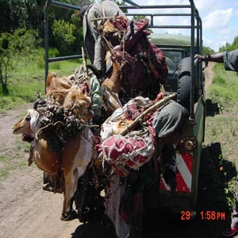
An entire herd of impala confiscated by authorities on the western boundary of the Mara.
Photo by James Evanson Kariuki (Ann K Taylor Fund).

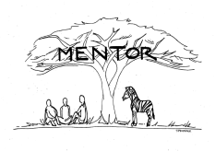
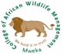
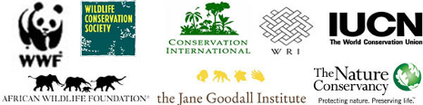

Introduction

This concept paper explains how the USFWS MENTOR Fellows are laying the foundation for a regional approach to address the bushmeat problem in eastern Africa and how they are working together as a team to implement this strategy.

Background on Bushmeat in Eastern Africa

One of the greatest conservation challenges facing us today is the rapid decline of wildlife populations that are being hunted for food in Africa. The trade in such 'bushmeat' is estimated to represent an even greater threat to the survival of wild animal species than does deforestation (Barnett 2000). Bushmeat applies to all species of wildlife that are killed and the meat consumed at the local household level or sold as a source for generating income. Species range from elephants to rodents. Bushmeat is derived from wildlife harvested using illegal hunting methods (e.g. snares, traps and guns), from endangered or threatened species, taken from parks and other protected areas, and/or taken for unsustainable commercial or non-commercial uses.

Important wildlife resources in the eastern Africa countries of Kenya, Southern Sudan, Tanzania, and Uganda are threatened by habitat loss, fragmentation, illegal hunting and wildlife disease. Poverty and environmental degradation are heavily impacting on the wildlife. In particular eastern Africa is facing a serious decline in wildlife populations outside protected areas that is likely a result of the illegal bushmeat trade. Lack of awareness and transparency, inadequate policy, poor wildlife law enforcement and unsuccessful prosecution, need for protein, lack of economic alternatives, and political instability are key drivers of the bushmeat trade in eastern Africa. Yet due to sensitivity and prominence of wildlife-based tourism, as well as a strong focus on protected areas, illegal wildlife trade and consumption rarely occur openly. The underground nature of the bushmeat trade in this region has minimized the professional focus on this important issue for over a decade. Unfortunately, the impacts are now becoming obvious as a major cause of the precipitous decline of large mammal populations across eastern Africa.

The illegal bushmeat trade affects threatened and endangered species in particular, and can threaten overall biodiversity conservation goals. It impacts ecosystems in various ways, such as when critical seed dispersers are removed or keystone species are extirpated. The bushmeat trade poses human health risks as it contributes to the ease of zoonotic disease transmission. It may result in a potential decline in tourism as wildlife populations are impacted and tourists see snared, injured, and dead animals and hear gunshots at night.

Most of the research, work and attention on bushmeat have focused on West and Central Africa due to the scale and visibility of the problem. According to the Bushmeat Crisis Task Force (BCTF), the scale of the commercial bushmeat trade in West and Central Africa is driven by markets with high human densities and population growth. The commercial market in these regions has resulted in local wildlife extinctions and jeopardizes the survival of existing species. In some instances this has resulted in forest areas devoid of wildlife populations.

Illegal bushmeat exploitation is believed to be growing significantly in eastern Africa in recent years. In eastern and southern Africa, the last comprehensive documentation of the commercial bushmeat trade and its impacts on wildlife populations was published by TRAFFIC in 2000 (Barnett 2000).
Problem Statement

Wildlife across eastern Africa is declining rapidly both inside and outside protected areas. Species such as Mountain Reedbuck and Klipspringer have become locally extinct in some parts of Tanzania (Newmark et al. 1991). Wildlife utilization in the region is mostly uncontrolled with increased demand resulting from human population increase that has exceeded the productive capacity of the affected wildlife populations. In Uganda, for example, black and white rhino, Derby elands and, Oryx have experienced localized extinctions. The 2006 – 2008 List of the World’s 25 Most Endangered Primates has seven species from Africa including the kipunji from Tanzania and Tana River red colobus monkey from Kenya. Bushmeat utilization in the region is seriously impacting the number and abundance of wildlife species involved resulting in overexploitation of wildlife. Some species such as elephants, buffalo, eland, greater kudu and Abbot’s duiker that used to be plentiful are currently reported threatened or nonexistent in most of their original habitats (Foya and Binamungu 2000).

Summary of Current Status of Biodiversity Targets in Eastern Africa

The illegal bushmeat trade in eastern Africa targets some species directly and others indirectly.
Key biodiversity targets specifically hunted for their meat include large and small migratory and sedentary ungulates, hippopotamus, primates, and elephants. Carnivores are impacted secondarily by reduction in their prey base or getting caught in snares. The term “biodiversity target” in this context refers to species being impacted by the bushmeat trade.

- Tiang: Current research indicates that the Tiang typically supply 60-70% of the meat available in bushmeat markets across Jonglei landscape in Southern Sudan. Years of commercial-level exploitation coupled with civil war have resulted in considerably reduced Tiang populations in many areas. For example, WCS estimated tiang populations in the Boma-Jonglei landscape as 384,918 individuals in the early 1980s. In 2007, surveys estimated only 166,953 Tiang remaining. Projections for Tiang populations in the long-term suggest dramatically decreasing trends. This is believed to be due to the bushmeat trade (WCS 2007).

- White Eared Kob: The war in Southern Sudan is impacting the population of White Eared Kob in the Boma-Jonglei landscape. In the early 1980s, WCS estimated that there were 861,137 kob. This was reduced to 816,252 individuals in 2007 (WCS 2007). White Eared Kob are directly impacted by bushmeat consumption and trade.

- Hippopotamus: A1996 assessment showed Common Hippo populations as widespread and secure. Since then, there have been substantial changes in their numbers in many countries. Recent population estimates suggest that over the past 10 years there has been a 7–20% decline in Common Hippo populations. Over three generations (approximately 30 years), it is likely the population reductions will exceed 30% size reduction considering both past and future trends. Although the causes of the population decline are known (exploitation and habitat loss), the threats have not ceased, nor is there evidence the threats will be removed in the near future. Therefore, the species is listed as Vulnerable in the IUCN 2008 Red List of Threatened Species (IUCN 2008). East Africa holds substantial numbers of hippos with 30,000 in eastern DR Congo and populations numbering tens of thousands in Ethiopia, Sudan and Tanzania. Several thousand also occur in Kenya and Uganda bringing the total for East Africa as a whole to about 70,000. Hippos are often targeted species in the bushmeat trade.
- Elephants: According to counts in 2007, elephant populations in East Africa totaled 180,846 individuals (including 30,000 in Kenya, 146,646 in Tanzania, and 4,200 in Uganda (IUCN 2007). In 1979, an aerial survey showed a population estimate of 133,000 elephants in Southern Sudan (Sudan Study on Biodiversity 1979). A survey conducted by WCS (2007) in Boma and the Jonglei landscape showed that in the early 1980s there were 6,117 elephants in Boma and Jonglei and now there are 7,195. However in Southern National Park in the early 1980s, there were 10,960 while now only 589 elephants remain. Previously the main threat to elephants was ivory trade, which resulted in poaching and the decrease in elephant population numbers. However, currently, the threat to elephants has increased and includes habitat destruction or loss due to deforestation, expansion of agricultural activities, increase in human population, and bushmeat hunting.

- Cheetahs: Over the past 50 years, cheetah has become extirpated in at least 13 countries (Marker, 1999). The two remaining strongholds are in Kenya and Tanzania in East Africa and Namibia and Botswana in southern Africa. Southern Sudan is believed to have a considerable number of cheetah, however, since the period of conflict there has been no systematic survey conducted to establish trends and the population of cheetah in this country. During a survey conducted by NSWCO in Boma in 2001 and 2002, a number of cheetah were sighted. In other parks such as Southern National Park and other game control areas in Southern Sudan, NSWCO 2003) sighted many cheetah. Yet there have been no formal counts on cheetahs conducted by the Ministry of Wildlife Conservation and Tourism in Southern Sudan since its establishment after the signing of the comprehensive agreement in 2005 in Kenya. The cheetah specialist group has no information about cheetah populations in Southern Sudan. Although the cheetah face different problems in different parts of their range, the main causes of decline are human-cheetah conflict and inter-species competition. As humans turn more and more land into farmland for livestock production, the cheetah’s habitat has become fragmented. Additionally, in some countries cheetah are indiscriminately killed as possible livestock predators. Low genetic diversity further makes cheetah more susceptible to ecological and environmental changes, as well as more vulnerable to disease. There has not been a comprehensive census of cheetah since 1975, when it was estimated that there were from 7,000 to 23,000 animals in 25 countries (Myers 1975). Today, it is believed that fewer than 15,000 cheetahs remain. Population estimates in most other cheetah range countries indicate that as much as 90% of cheetahs live outside of protected areas. Cheetahs are indirectly impacted by the bushmeat trade.

- Wild Dogs: Wild dogs have been extirpated across much of Africa in the past 30 years. Ginsberg and Woodroffe (1997) estimate the size of remaining populations at between 3,000 to 5,000 free ranging wild dogs in Africa. In eastern Africa, the estimate is 2,200 (with 350 estimated in Kenya, 1800 in Tanzania, and 50 in Southern Sudan). Yet the wild dog population in Southern Sudan could be more than estimated as protected areas such as Boma National Park and Southern National Park are believed to have a number of wild dogs as evidenced by communities around these parks still considering wild dogs as killers of domestic animals, dangerous and unwanted. No conservation organizations or wild dog specialist groups are currently active in Southern Sudan in order to estimate the population size. The wild dog has been extirpated in Uganda. The principal threat to wild dogs is conflict with human activities and infectious disease. Both of these are increased with habitat fragmentation, which increases contact between wild dogs, people and domestic dogs. Wild dogs are secondarily impacted by the bushmeat trade.

- Lions: Over the past 20 years, the number of lions is suspected to have dropped dramatically to a population estimated between 23,000 to 39,000 across Africa. Lions have disappeared from over 80% of their former range. The lion was classified as vulnerable on the IUCN red list of threatened species in 2004 due to a continuing decline in population. In eastern Africa, the total population of lions in Uganda was estimated at 619 in 2002 by Chardonnet and at 575 in 2004 by Bauer and Van Der Merwe. Conservative estimates for the total lion population for Sudan was estimated at 800 in 2002, but no general estimates have been made for lion populations in the national parks in Southern Sudan during and since the war. Therefore, no data is available although there are believed to be a considerable lion population in the country. The Kenya population of lion declined from an estimate of 10,000 in the 1970’s to 2,749 in 2002 and to 2,280 in 2004 (Chardonnet 2002). Tanzania has the largest lion population on the continent and they are not threatened in that country. Exact data is lacking overall but the lion population is likely being reduced in areas with high human population growth, expansion of agriculture and livestock husbandry and in some areas of the north-western Tanzania where an influx of refugees has occurred. Lions face an indirect threat from the bushmeat trade.

- Leopards: Leopards are declining in number. According to the IUCN Red List of Threatened Species (IUCN/SSC Cat Specialist Group 2002), “based on estimates of density and geographic range the leopard's total effective population size is estimated at greater than 50,000 mature breeding individuals, but with a declining trend due to persecution and degradation of its habitat and prey base (Nowell and Jackson, 1996).” An up-to-date leopard population estimate and trends in population are not available for eastern Africa; however, leopards are increasingly impacted by farmers, pastoralists and illegal hunters. Leopards are indirectly impacted by the bushmeat trade.

Definition

The term “bushmeat” is defined as all species of wildlife that are illegally killed and the meat consumed or sold as a source of income.

Vision, Goal, and Objectives

In order to address the bushmeat problem, the USFWS MENTOR Fellows developed the following vision, goal, and objectives.

Vision

A bushmeat-free eastern Africa through increased protection, alternatives, awareness and sustainable utilization of wild fauna to conserve the region’s rich biodiversity for the benefit of present and future generations.

Goal

By 2013, there will be 50% reduction (from 2008 estimates) in bushmeat off take in and around key protected areas in eastern Africa due to increased capacity to effectively address the bushmeat problem.

Team Initiative and Pilot Implementation Project Objectives

The USFWS MENTOR Fellows will work regionally and nationally as teams to conduct pilot implementation projects in key protected areas in eastern Africa to:
- Provide comprehensive and factual communication to multiple stakeholders on the bushmeat issue in eastern Africa,
- Build an interdisciplinary network for information exchange, promoting bushmeat strategies and solutions, and advocating the resolution of the bushmeat problem in eastern Africa,
- Establish and constantly update a bushmeat information base for eastern Africa,
- Carry out wide-ranging bushmeat awareness campaigns,
- Improve the ability of magistrates, prosecutors and police to undertake law enforcement and prosecution of bushmeat crime by increasing their understanding on the value of wildlife and providing case precedence throughout East Africa,
- Leverage partnerships for implementing protein alternative projects, and
- Work with partners to help reform ex-poacher groups and support them to adopt alternative income generating activities.

Background on USFWS MENTOR Fellowship Program

The USFWS MENTOR (Mentoring for Environmental Training in Outreach and Resource conservation) Fellowship program is an initiative of the U.S. Fish and Wildlife Service (USFWS), the College of African Wildlife Management-Mweka, Tanzania, and the Africa Biodiversity Collaborative Group (a consortium of U.S. based international conservation non-governmental organizations including African Wildlife Foundation, Conservation International, IUCN-The World Conservation Union, the Jane Goodall Institute, The Nature Conservancy, Wildlife Conservation Society, World Resources Institute, and World Wildlife Fund). The 2008/2009 program addresses the need for action to curtail illegal bushmeat trade in eastern Africa. The program invests in capacity building, training and career development of emerging conservation leaders in order to build a network of eastern African wildlife professionals who can lead efforts to reduce illegal and unsustainable bushmeat exploitation at local and regional levels.

In February 2008, eight USFWS MENTOR Fellows from Kenya, Southern Sudan, Tanzania, and Uganda, were selected to participate in the 18 month post-graduate diploma program. The Fellows spend approximately 6 months at the College of African Wildlife Management taking specially designed coursework on bushmeat solutions and challenges. The Fellows are in the field for approx. 12 months working under the guidance of experienced conservation Mentors to conduct bushmeat field assessments (at the national and site levels) and to implement pilot projects on bushmeat solutions. (See: www.mentorfellowshipprogram.org.)

Field Assessment Results

In order to collect data and better understand the bushmeat trade in Kenya, Southern Sudan, Tanzania, and Uganda, the eight Fellows conducted national and site level assessments in April and May 2008. Following in Box 1 and Box 2 are some results of their assessments.

Box 1: Field Assessment Results by USFWS MENTOR Fellows

 | Mr. Evanson Kariuki (Fellow-Kenya) conducted his bushmeat field assessment in Maasai Mara Ecosystem, Kenya.  Evanson Kariuki surveyed eighty-seven respondents in the Maasai Mara ecosystem in Kenya. The key finding was that poaching for bushmeat is increasing. Over the last five years, 11,398 snares and 895 other trapping devices were confiscated. In the Maasai Mara, bushmeat is a cross border issue with Tanzania. The drivers of the bushmeat trade are income, protein and culture. Species affected by the bushmeat trade include wildebeest, zebra, buffalo, hippo and impala. There is currently low awareness on the impacts of the bushmeat trade.
 | Mr. Iregi Mwenja (Fellow-Kenya) focused on the effects of wildlife policy on bushmeat poaching and ranching In Kenya.  The current wildlife policy in Kenya bestows ownership of wildlife to the state, and generally restricts any form of consumptive use particularly after the 2003 moratorium on game cropping in game ranches. Wildlife occurring on private or communally-owned land (75% of which generates tourism revenue) is therefore seen as a liability and in some cases “a pest best removed”. As a consequence of this restrictive policy, land-owners (ranchers) no longer invest in wildlife protection and management leading to rise in bushmeat poaching and commercialization of the bushmeat trade in these non-protected areas. The rate of habitat loss has been accelerated as land-owners convert suitable natural wildlife habitat to other land uses that can generate revenue. The shrinking habitat has driven wildlife closer to the people leading to an escalation of human wildlife conflict.
 | Mr. Isaac Seme (Fellow-Southern Sudan) did his study in Bor and Badingillo National Park, Southern Sudan.  Isaac Seme surveyed more than sixty people in Bor and Badingillo National Park in Southern Sudan including 23 hunters, 20 consumers and 20 wildlife managers. Key findings were that bushmeat consumption has increased and wildlife populations are dropping. The most hunted species are Tiang, Mongalla gazelle, warthog, hippo, bushbuck, and buffalo. Species disappearing the most include zebra, buffalo, and common eland. The major hunting method is automatic rifles. There is inadequate law enforcement and awareness on bushmeat.
 | Mr. Peter Amum (Fellow-Southern Sudan) focused his research on Boma National Park, Southern Sudan.  Peter Amum surveyed eighty-six people in Boma National Park in Southern Sudan including 58 consumers, 21 hunters and one trader, two wildlife officers and five game scouts. The key finding was that bushmeat is the main source of protein and income for the communities in this area. Twenty-one species were illegally hunted of which 85% were herbivores. White-eared kob and Mongalla gazelle were the most targeted species. The main hunting tool was automatic rifle. Wildlife species that are decreasing include elephant, buffalo, giraffe and zebra. Inadequate law enforcement is a huge problem and the park currently lacks adequate human and technical capacity.
 | Ms. Lowaeli Damalu (Fellow-Tanzania) conducted her analysis on urban centers in Morogoro and Kilombero districts, Tanzania.  Lowaeli Damalu interviewed more than 350 people in the urban centers of Morogoro and Kilombero Districts of Tanzania including 22 key stakeholders, 33 hunters, and 303 consumers. More than 90% of the respondents were aware that the bushmeat trade is increasing from subsistence use to commercial trade. Bushmeat from Tanzania is exported outside the country to Kenya, Zambia, Malawi and the Far East. Wildlife populations, especially ungulates are decreasing. The estimated volume of bushmeat confiscated every year is about 2,078,694.83 kg per year. Institutional capacity to deal with the bushmeat problem is inadequate in terms of funding, manpower, and knowledge. There is inadequate monitoring, inspection and supervision of subsistence hunting.
 | Mr. Martin Andimile (Fellow-Tanzania) conducted his field assessment in and around Katavi National Park, Tanzania.  In and around Katavi National Park, Martin Andimile surveyed 120 households, 4 poachers, and 2 park wardens. The bushmeat trade was found to be increasing due to commercial trade. The main hunting method used was muzzle loader. The bushmeat from Katavi is exported outside the country to the Democratic Republic of Congo, for example. Poaching in Katavi National Park is increasing as law enforcement is insufficient. There is little awareness about wildlife laws and the value of wildlife. The drivers of the bushmeat trade include culture, protein and income use.
 | Mr. Okello Genesis (Fellow-Uganda) focused his assessment on urban areas in Uganda: Gulu, Kasese, Masindi, and Kampala.  More than two hundred respondents were surveyed by Okello Genesis in four urban centers of Uganda (Gulu, Kasese, Masindi and Kampala) including 80 traders, 80 consumers, 40 police, and 30 wildlife officers. The key findings are that wildlife populations are declining and there are local extinctions. The origin of the bushmeat is from Murchison Falls National Park and Queen Elizabeth National Parks. The main drivers of the illegal bushmeat are taste, poverty, and culture. Bushmeat is important to livelihoods. There is currently inadequate awareness of the linkages between bushmeat and disease, about wildlife laws, and the value of wildlife. Law enforcement is insufficient. The preferred species for the bushmeat trade are hippo, buffalo, and warthog. Species that are disappearing from the trade include hippo, buffalo, and elephant.  
Mr. Vincent Opyene (Fellow-Uganda) looked at the legal regime and institutional governance of bushmeat utilization In Uganda and Tanzania

One hundred and forty people including prosecutors, police, law enforcement wardens from protected areas, state attorneys, and magistrates were surveyed by Vincent Opyene in Uganda and Tanzania in order to gain an understanding about legal regimes and institutional governance regarding bushmeat utilization. The key finding was that there is inadequate awareness of wildlife laws by law enforcers. The forensic equipment for proving cases is inadequate. In Tanzania, use of the Economic Crime Act contributes to the failure in prosecuting wildlife cases.

The laws in Uganda currently have no provision for the financial values of wildlife while the laws in Tanzania have no provision for other wildlife values.
photo credits: RARE and Heather Eves

Box 2: Similarities and Differences Found Across the Region from Bushmeat Assessments

Across the eastern Africa region, the Fellows found the following commonalities on the illegal bushmeat trade:
- In all countries, wildlife populations are decreasing, and bushmeat is considered to be common cause of this.
- There is inadequate awareness on wildlife laws, the impact of bushmeat, and the linkages between bushmeat and emerging infectious diseases.
- Law enforcement, capacity to deal with the bushmeat issue, and technology for identifying bushmeat are inadequate across the countries.
- Collaboration to deal with the bushmeat issue is poor among stakeholders.
- The drivers for the illegal bushmeat trade are common across the region.
- The hunting tools and methods used across the region are common.

However, there were also regional differences regarding:
- Policies and laws vary widely among the countries.
- The value attached to wildlife differs from country to country, from both the socio-economic and legal perspectives.

Adaptive Management and Planning for Long-Term Bushmeat Effort

In order to develop a regional strategy for planning long-term efforts to deal with the bushmeat problem in eastern Africa, the Fellows used the lessons from their bushmeat field assessments and their professional experience to work with experts from Foundations of Success, the Bushmeat Crisis Task Force, and The Nature Conservancy on adaptive management. Using adaptive management methodology, the Fellows developed a conceptual model for a regional strategy on the bushmeat trade to be conducted through team efforts. The Fellows did the following:
- Defined the project participants including the Fellows, Mentors, donors, advisors, key stakeholders in each country (e.g. park staff, ministry staff, private industry, local communities, hunters, traders).
- Defined the direct threats: market bushmeat poaching and trade vs. household bushmeat poaching and trade.
- Identified components/criteria for each direct threat along with assigning objectives and indicators for each.
- Drafted conceptual model for a regional bushmeat strategy and results chain for the Team Initiative to show the actions that will be taken to get the desired results for implementing the regional strategy. (See: Figure 1: Strategies to Address the Eastern Africa Bushmeat Trade Conceptual Model).
- Defined Team Initiative where all Fellows will support building the Bushmeat-free Eastern Africa Network (BEAN). All Fellows will work on some component of the team initiative in their respective countries and all will be responsible to developing components of the overall communications strategy, partnership building strategy, and awareness strategy
(See: Box 3).

Box 3: Team Initiative for Implementing Bushmeat Strategy

Build a Bushmeat-free Eastern Africa Network through:
- Communication Strategy Development and Implementation
- Partnership Building
- Awareness Strategy
- Information Management

Implement Pilot Projects in Key Protected Areas on:
- Awareness Campaign
- Protein Alternatives Partnerships
- Income Alternatives Partnerships
- Law Enforcement and Prosecution

Based on the regional strategy for reducing bushmeat off take, the Fellows prioritized the need for developing a Bushmeat-free Eastern Africa Network (BEAN) (See: Box 4).

Box 4: Bushmeat-free Eastern Africa Network (BEAN)

BEAN would be built from 2008 to 2011 through the development and implementation of a regional communications strategy, partnership building, bushmeat awareness strategy and information management system.

BEAN will be an interdisciplinary network consisting of the Fellows, Mentors, and other wildlife and development professionals who work to raise awareness, focus attention, share information, and leverage resources to implement grassroots solutions to bushmeat exploitation problems affecting eastern Africa.

Output 1 | Bushmeat-free Eastern Africa Network (BEAN) Action Plan
Output 2 | At least one partnership MOU between government, development, conservation and/or other NGOs and institutions to work together on bushmeat. This could include private industries (e.g. tourism, hotel, etc.), development agencies (e.g. USAID, CARE, Save the Children, UNHCR), conservation NGOs, academic and research institutions, and/or government agencies (e.g. tourism, wildlife, justice, poultry, livestock, etc.)
Lead | USFWS MENTOR Fellows and Mentors
Information Management

The Fellows will work with the Bushmeat Crisis Task Force (BCTF) to produce an integrated information base for eastern Africa via the Bushmeat Information Management and Analysis Project (IMAP) and other venues. This information base will be developed by the Fellows.

Output 1 | Four BCTF bushmeat project report forms filled out for each of the four countries.
Output 2 | For Kenya, ten BCTF projects will be evaluated and summary report produced  for the Kenyan community.
Lead | Mr. Iregi Mwenja (with USFWS MENTOR Fellows and Mentors contributing continuous information and project reports).

The Fellows also singled out the need for local protected area level strategies focusing on bushmeat awareness, protein alternatives, income alternatives, and law enforcement and prosecution. (See: Box 5.) These activities would be carried out through partnerships bringing different stakeholders together under agreements such as Memorandums of Understanding (MOUs). (See Box 6. for sample partnership MOU.)

Box 5: Pilot Implementation Projects in Key Protected Areas
1 September 2008 to 31 May 2009

The Fellows will conduct stakeholder workshops and pilot implementation projects addressing bushmeat mitigation on awareness, law enforcement, and/or alternatives in four key protected areas.

Four protected areas in Kenya, Southern Sudan, Tanzania, and Uganda were selected for the Team Initiative and Pilot Projects based on the following criteria: high source of bushmeat, species diversity, popular tourist destination, and high vulnerability.

- Maasai Mara Game Reserve, Kenya (in close collaboration with Serengeti pilot).

Output 1 | Partnerships leveraged with the goal of achieving an MOU with development agency, conservation NGOs, and other partners to work on bushmeat awareness
Lead | Mr. Evanson Kariuki (in close collaboration with Ms. Lowaeli Damalu and Mr. Martin Andimile)
- Serengeti, Tanzania (in close collaboration with Maasai Mara pilot).

Output 2 | Partnerships leverage with the goal of achieving an MOU with development agency, conservation NGOs, and other partners to work on protein alternative project with site level work with communities adjacent to Serengeti
Leads | Mr. Martin Andimile  Ms. Lowaeli Damalu (in close collaboration with Mr. Evanson Kariuki)
- Jonglei Landscape, Southern Sudan

Output 3 | Awareness campaign conducted in the Jonglei Landscape in Southern Sudan at both the national and local level (highlighting key biodiversity targets such as Tiang in Bor and Badingilo National Park and White Eared Kob in Boma National Park).
Leads | Mr. Isaac Seme  Mr. Peter Amum
- Murchison Falls Conservation Area, Uganda

Output 4 | Partnerships leveraged with the goal of achieving MOU with development/private industry and Uganda Wildlife Authority on income generating alterative projects with Uganda Reformed Poachers group in Murchison Falls, Uganda.
Lead | Mr. Okello Genesis
- Eastern Africa Region
Output 5 | Manual produced on prosecution of wildlife crimes and strengthening done on understanding of the value (economic and ecological) of wildlife and seriousness of the impacts of wildlife laws among magistrates, prosecutors, and police on wildlife law in key protected areas in Kenya, Tanzania, and Uganda.
Lead | Mr. Vincent Opyene (with assistance in Maasai Mara by Mr. Evanson Kariuki, in Serengeti by Ms. Lowaeli Damalu and Mr. Andimile Martin, and in Murchison Falls with Mr. Okello Genesis.)

Box 6: Sample MOU
SAMPLE
MEMORANDUM OF UNDERSTANDING BETWEEN
UGANDA WILDLIFE AUTHORITY, WILDLIFE CONSERVATION SOCIETY -UGANDA
AND UGANDA TAXI OPERATORS ASSOCIATION

PREAMBLE:
This Memorandum of Understanding (MOU) is between the Uganda Wildlife Authority here in referred to as UWA, the Wildlife Conservation Society here in referred to as WCS, and the Uganda Taxi Operators Association here in referred to as UTODA herein after jointly referred to as the parties.
RECOGNISING the principle of the independence of these three organizations
CONSCIOUS of the benefits to be derived from close cooperation in control of illegal wildlife utilization in Uganda
ACKNOWLEDGING the necessity to conserve the unique wildlife of Uganda for the benefit of future generations
WHEREAS UWA, WCS and UTODA agreed on the necessity to cooperate in fighting illegal bushmeat transportation to commercial centers
This memorandum of understanding is made this …………………day of …………2008 between UWA, WCS and UTODA P.O Box ……. Kampala, Uganda

The parties hereby agree as follows:
Article 1 Modes of operandi
1.0 All parties agree that this MOU is not intended to limit collaboration between the parties and other organizations or individuals neither shall any of the parties have the authority to bind or represent the other parties in dealing with third parties.
Article 2 UWA obligations
UWA shall work with WCS and UTODA as far as possible in specified activities and in accordance with provision of this agreement and shall do the following:
2.1 Take lead in prompt investigation and communication of all matters pertaining to arrest and prosecution of any illegal trader in wildlife products arrested during transportation with the help of UTODA
2.2 Assist in education and awareness raising on illegal wildlife trade among UTODA officials, drivers and conductors working in different routes.
2.3 Work with UTODA to reduce illegal transportation of wildlife and wildlife products to commercial centers.
2.4 Use Taxis under the management of UTODA to carry banners and spread the conservation messages to the general public.
Article 3 WCS obligations
WCS shall work with UWA and UTODA as far as possible in specified activities and in accordance with provision of this agreement and shall do the following:
3.1 Provide technical advice and data on bushmeat to assist UWA and UTODA
Article 4 UTODA`S obligations
UTODA shall work with UWA and WCS as far as possible in specified activities and in accordance with this agreement and shall do the following:
4.1 Inform UWA and WCS through their taxi drivers and conductors of any luggage they are suspicious of to be wildlife or wildlife products.
4.2 Provide opportunities for staff to undertake trainings provided by UWA and WCS to promote capacity building in the areas of detection of illegal transportation of bushmeat or any other wildlife trophy
4.3 Identify taxi owners interested in carrying banners for bushmeat campaign on their taxi
4.4 Identify places where bushmeat is poached through their drivers and conductors
4.5 Use its country wide network and staff to make contacts with potential donors and solicit donations for implementation of agreed programs.
4.6 Develop a management plan outlining proposed initiatives required resources and anticipated outcomes and benefits to the organizations which shall be approved by all parties.
Article 5 Reporting
5.0 UTODA shall provide UWA and WCS with monthly and annual reports regarding activities implemented as agreed.
Article 6 Ownership of data and other assets: It is agreed between all parties that:
6.1: In the spirit of professional conduct, institutional collaboration, and national interest, all parties shall when appropriate include and acknowledge the other in research studies, scientific publications and/or presentations and give credit where it is due
6.2: Scientific results arising from joint studies or operations between UWA, WCS, and UTODA shall be jointly owned and all parties shall retain access without inhibition
Article 7 Disputes
7.0 Any disputes between parties hereto arising from or related to interpretation of this agreement or its enforcement shall be amicably settled between all parties or referred to an arbitrator appointed by all parties should this fail then the arbitration law of Uganda shall apply.
Article 8 Amendments and Termination
8.0 This MOU shall supersede any and all previously executed MOU and all other agreements and understandings whether verbal or written between both parties with respect to collaboration on wildlife conservation in Uganda and shall remain in force for an initial period of five years from the date of execution, but may be reviewed from time to time as it may necessitate and any amendments will be in writing on the agreement of all parties. All parties may for a good cause terminate this agreement by giving three months written notice to the other parties.

IN WITNESS WHEREOF the undersigned being duly authorized thereto have on behalf of UWA, WCS and UTODA signed the MOU on the date and year affixed below.

SIGNED SEALED and DELIVERED for UWA
Signature………………………………………………………..
Name and Title…………………………………………………
Address………………………………………………………….
Date……………………………………………………………...

SIGNED SEALED and DELIVERED for WCS
Signature………………………………………………………..
Name and Title…………………………………………………
Address…………………………………………………………..
Date……………………………………………………………….

SIGNED SEALED and DELIVERED for UTODA
Signature………………………………………………………..
Name and Title…………………………………………………
Address…………………………………………………………..
Date……………………………………………………………….

Building the capacity of CAWM to provide future and continued training on bushmeat was also considered a priority, as described in Box 7 below.

Box 7: Capacity of the College of African Wildlife Management, Mweka, to Provide Training on Bushmeat

Mweka College builds its capacity to integrate the subject of bushmeat into their curriculum and train African wildlife professionals in the future.

Output 1 | Develop curricula for each training module provided through MENTOR for review and refinement by Mweka leadership/faculty
Output 2 | Organize a conference at Mweka College in June 2009 to share results of the USFWS MENTOR Fellowship Program with a broader BEAN community
Leads | Mr. Freddy Manongi  Mr. Hamidi Dulle

The detailed results chains developed by the Fellows through the adaptive management process appear in Appendices 1 through 8. These results chains are illustrative. They provide background, objectives and monitoring plans for building BEAN and implementing pilot projects in the key protected areas identified. (See:
Appendix 1: Communication Strategy Development and Implementation
Appendix 2: Partnership Building
Appendix 3: Awareness Strategy
Appendix 4: Information Management
Appendix 5: Awareness Campaign in Key Protected Areas
Appendix 6: Protein Alternatives Partnerships
Appendix 7: Income Alternatives Partnerships
Appendix 8: Law Enforcement and Prosecution.)

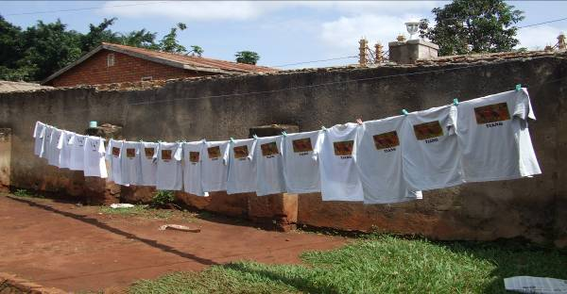
Tiang T-Shirts for bushmeat awareness campaign being produced, September 08.
Photo credit: Isaac Seme.
Figure 1: Strategies to Address the Eastern Africa Bushmeat Trade Conceptual Model

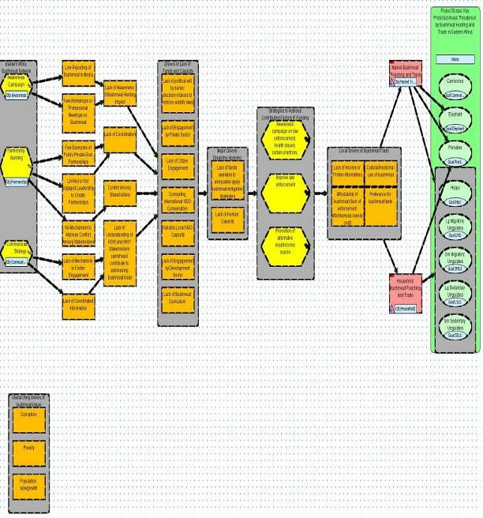
Communications and Pilot Implementation Project Management

In order to monitor the impact of the team initiative and pilot implementation projects, the USFWS MENTOR Fellows are communicating regularly with each other, their Mentors, the Program Coordinator, Mweka Facilitators, USFWS, BCTF and other partners. Regular communication activities include monthly team conference calls, circulating the Fellows’ monthly project reports, and regular email exchanges.

As communication is critical to fostering bushmeat solutions, the Fellows conducted the following SWOT Analysis in Table 1. They also identified each team members’ strengths in Table 2 below.

Table 1; SWOT Analysis of USFWS MENTOR Fellows Communications

Strengths (Internal) | Weaknesses (Internal)
• Solid team foundation  • Everyone on team has strong background on bushmeat challenges and solutions  • Strong, clear vision statement motivates the team’s work  • Everyone involved in the project understands the importance of communications | • Outreach activities require expansion of staff  • Lack of funding for increasing staff and project  related travel  • Coordinating meetings with Fellows is  challenging due to geographical spread
Opportunities (External) | Threats (External)
• Volunteers may be willing to assist in the  development of communications materials, and website development | • Lack of participation by volunteers  • Political instability
Conclusions:
Many opportunities exist to contribute to the success of the USFWS MENTOR Fellows’ communications strategy in order to meet the goal of information sharing and distribution among field projects and members of the public. The team has demonstrated its strengths and weaknesses. Outreach activities will require increased attention and staff resources. Certain threats to the success of the strategy exist and include lack of commitment to data sharing among stakeholders who may reduce the effectiveness and utilization. Political instability throughout the region could hamper coordination efforts and opportunities as well as access to technological infrastructure. Due to its small size and limited resources, the Fellows will plan to take advantage of all existing opportunities to harness external skills and expertise to meet their communication goals.

Table 2. Understanding and Utilizing Team Member’s Strengths

Team Member  (USFWS MENTOR Fellows) | • What project-relevant knowledge and experience does this person possess?  • What general strengths do they bring to this project? | How can the team of USFWS MENTOR Fellows best utilize this expertise and set of strengths?
Mr. James Kariuki Evanson  PO BOX 8914 00 100  Nairobi, KENYA  +254 722 98 43 01  jmkevanson@yahoo.com | • Knowledge of bushmeat issues and desnaring campaigns  • Background in public administration | • Use law enforcement field experience to outline strategies for local communities and ex-poachers groups
Mr. Iregi Mwenja  PO Box 606 Ruaraka 00618  Nairobi, KENYA  +254 723 713642  iregim@yahoo.com  skype: iregi.mwenja  www.bushmeateastafrica.wildlifedirect.org | • Knowledge of bushmeat issues in East Africa  • Experience in implementing the  information management and communications strategy  • Experience in fundraising for conservation projects  • Knowledge of wildlife laws and policies in Kenya  • Experience in law enforcement on anti-poaching | • Use the knowledge of bushmeat issues to help define target species for protection and their threats and effective strategies to reduce these threats  • Use experience in information  management and communications to outline an effective strategy and identify the activities and budget required to implement the strategy
Mr. Isaac Seme Solomon  Lecturer  Boma Wildlife Training Center  c/o WCS- SUDAN  BOMA, SOUTHERN SUDAN  iseme65@yahoo.com | • Experience with group facilitation, discussion, and training  • Experience managing small-scale projects  • Experience with financial and resource management  • Good task management skills | • Team can benefit from skills in facilitation and task management
Mr. Peter Amum  Wildlife Advisor  Wildlife Conservation General Administration HQ  P.O Box 336  Khartoum, SUDAN  +249 912434093  p_amum@yahoo.com | • Experience in wildlife management | • Use knowledge of wildlife to help determine wildlife management opportunities

Ms. Lowaeli Damalu  Law Enforcement Officer  Wildlife Division  PO Box 1994  Dar Es Salaam, TANZANIA  +255 784 660 701  lowaeli@yahoo.co.uk | • Experience in fundraising for conservation projects  • Experience in bushmeat issues and wildlife conservation in general  • Ability be a leader |  | • Use these skills to help identify sources of funds and fundraising  strategies
Mr. Andimile Martin  PO Box 878  Arusha, TANZANIA  +255 (0) 784 702749  andimile@gmail.com | • Experience coordinating field projects (that lacked well-defined management plans)  • Familiar with wildlife poaching and community development  • Urban Planning  • Experience with document presentation and file organization | • Use the understanding of poaching issues to help define effective strategies  • Use organizational and presentation skills to manage data produced by the team
Mr. Okello Genesis  Assistant Warden Law Enforcement  Uganda Wildlife Authority  Kampala, UGANDA  +256 772 675805  okellogenesis@yahoo.com | • Comfortable working with many  types of people and enjoy teamwork  • Ability to be a leader  • Encouraging of others  • Familiar with bushmeat issues  • Experience in law enforcement | • Team can benefit from knowledge of bushmeat and conservation issues
Mr. Vincent Opyene  Senior Warden Prosecution  Uganda Wildlife Authority  plot 7 Kira Road Kamwokya  P.O. Box 3530  Kampala, UGANDA  +256- 0772591289  opyenevicent@yahoo.com | • Comfortable working with many  types of people and enjoy teamwork  • Ability to be a leader  • Encouraging of others  • Familiar with bushmeat prosecution | • Team can benefit from knowledge of bushmeat prosecution

Future Needs

After the initial nine month pilot implementation projects (1 Sept 08 through 31 May 09) and the program outreach and evaluation period (1 June to 31 July 09), efforts are needed to continue the team initiative by the USFWS MENTOR Fellows, their Mentors, and other partners, and to solidify the Bushmeat-free Eastern Africa Network (BEAN). Future needs from August 2009 to July 2011 include:

- Supporting to Kenya Wildlife Service, Directorate of Wildlife- Southern Sudan, Tanzania Wildlife Division, and Uganda Wildlife Authority to enable them to collect data on bushmeat and develop long-term response mechanisms. This could take the shape of a designated bushmeat desk officer in each of the national conservation authorities (along the lines of the elephant program coordinator at KWS, and MIKE and RAMSAR coordinator at TWD) whose work would be financially supported by the program for an initial period. For long-term sustainability, financing this role would have to be taken up by the organizations at the end of the initial period).

- Assisting Boma Wildlife Training Centre to conduct long-term research, training, outreach, and curriculum development for their faculty, students, NGOs, and government officials to develop capacity in Southern Sudan to address bushmeat drivers, challenges, and solutions.

- Hiring a BEAN Project Coordinator to manage the network to ensure that responsibilities are being met. This coordinator will collect bushmeat project information, develop a BEAN listserv and communications tools (e.g. website, e-newsletters), coordinate annual workshops, and organize a training session. This person would be based at a local or national NGO in the region.

- Hosting annual workshops on bushmeat with high level officials from Wildlife Authorities, USFWS MENTOR Fellows and Mentors, governmental and NGO conservation bodies, donors, development agencies, local communities, private sector, and professional associations.

- Organizing training sessions on a key bushmeat issue (e.g. DNA testing and prosecution training) as identified from the annual workshops and recommendations of the USFWS MENTOR Fellowship Program.

- Bringing USFWS MENTOR Fellows, Mentors, and Mweka faculty together for a study tour (e.g. to CAMACO in Zambia) to observe best practices and share the lessons learned and experiences of the USFWS MENTOR Fellowship Program.

- Arranging for the Fellows and Mentors to present a symposium at a major regional or international conservation conference to raise awareness on the bushmeat issue in eastern Africa.

- Conducting research on major bushmeat source areas and testing more variables (e.g. the demand of bushmeat at different prices verses some bushmeat substitutes).

- Expanding innovative projects into other priority protected areas such as Katavi National Park where bushmeat is believed to be significantly impacting wildlife populations.

- Hiring a scientific editor to help Fellows and Mentors to convert their bushmeat field assessment reports into journal article format, edit, prepare, and help to get the papers published into a special journal issue.

- Working with a media group to do radio dramas to promote bushmeat awareness across the region by engaging radio listeners through compelling stories.

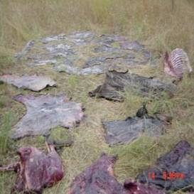
Bushmeat during Serengeti-Mara annual wildebeest migration (photo credit: J.E. Kariuki).
Timeline for USFWS MENTOR Fellowship Program – Pilot Implementation Projects
1 September 2008 to 31 May 2009

Activity |  | 2008 |  |  |  | 2009
 |  | S | O | N | D | J | F | M | A | M
Communications Strategy Development
Communication protocols determined |  | X | X | X
Communication tools/materials produced |  | X | X | X | X
Meetings and presentations held with stakeholders |  | X | X | X | X | X | X | X | X
Launch regional media campaign on bushmeat |  |  |  |  |  |  |  |  | X
Stakeholder evaluations completed |  |  |  |  |  |  |  |  |  | X
Partnership Building
Communication materials presented to potential partners  and stakeholders |  | X | X | X | X | X | X | X | X
Negotiations for partnerships undertaken |  |  |  | X | X | X | X | X | X | X
Analysis of partnership building results completed |  |  |  |  |  |  |  |  |  | X
Awareness Strategy
Preliminary assessment of the stakeholders |  | X | X | X
Identification of key messages to stakeholders |  |  |  | X | X
Implement awareness strategy |  |  |  |  | X | X | X | X | X | X
Post-assessment of the awareness strategy |  |  |  |  |  |  |  |  |  | X
Information Management
Bushmeat project report forms filled out and submitted to BCTF |  | X | X | X | X | X | X | X | X | X
Bushmeat-free Eastern Africa Network (BEAN) website and  weblog created and updated |  |  |  | X | X | X | X | X | X | X
Contacts made with key organizations in respective areas |  | X | X | X | X | X | X | X | X | X
Awareness Campaigns in Key Protected Area
Mobilization of community leaders, teachers, and religious  leaders |  | X | X | X | X
Meetings with community leaders, teachers, and  religious leaders |  |  |  | X | X | X | X | X | X | X
Negotiation towards MOUs |  |  |  |  | X | X | X | X | X
Evaluation of leaders and teachers |  |  |  |  |  |  |  |  |  | X
Protein Alternatives
Key stakeholders working on protein alternatives identified  and contacted |  | X | X | X
Presentations made to protein alternative agencies and private  sector on the bushmeat problem and discussion on partnerships  to work in communities adjacent to protected areas |  |  | X | X | X | X | X | X | X | X
Negotiation for partnership |  |  |  | X | X | X | X | X | X | X
Conduct meeting with all stakeholders in different villages |  |  | X | X | X
Evaluation of protein alternative partners |  |  |  |  |  |  |  |  |  | X
Income Alternatives
Preliminary assessment of reformed poacher groups |  | X | X | X
Identification of Income-Generating Alternatives (IGA) |  |  | X | X | X
Training in IGAs |  |  |  |  | X | X
Negotiate for partnership |  | X | X | X | X | X | X | X | X | X
Post-assessment of the IGA program |  |  |  |  |  |  |  |  |  | X
Law Enforcement and Prosecution
Organize appointments with law enforcement stakeholders  in Uganda |  | X | X
Kenya field assessment and appointments with law  enforcement stakeholders in Maasai Mara |  |  |  | X
Meetings with law enforcement stakeholders in Serengeti |  |  |  |  | X
Wildlife law enforcement partners consultative meetings |  |  |  |  |  |  |  | X | X
Writing of Prosecutors’ manual |  | X | X | X | X | X | X | X | X | X
Editing Prosecutors’ manual |  |  |  |  |  |  |  |  |  | X

Budget and Budget Notes
(See attached)

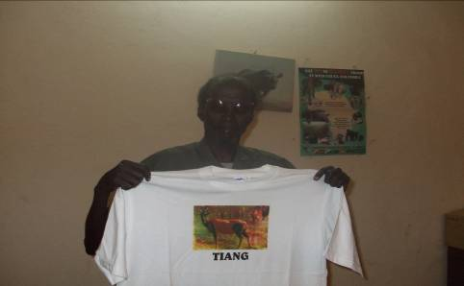
The Director General of the Ministry of Wildlife Conservation and Tourism in Southern Sudan, Major General Michael Chor, happily received his T-shirts of Tiang awareness program in Bor and Badingillo in October 2008. He has expressed his wiliness to support and address issues regarding bushmeat (photo credit: Isaac Seme)

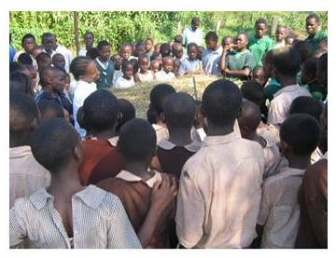
Environmental club discussing bushmeat at a school neighboring the Mara, Kenya in October 2008. (photo credit: J.E. Kariuki)
References

Barnett, R. 2000. Food For Thought: The Utilization and Trade of Wild Meat in Eastern and Southern Africa. TRAFFIC East/ Southern Africa. Nairobi, Kenya.

Bauer, H. and S. Van Der Merwe, S. 2004. Inventory of free ranging lions (P Leo) in Africa. Oryx 38(1):26-31.

Bauer, H., and S. van der Merwe. 2002. The African lion database. IUCN/SSC African Lion Working Group. http://www.african-lion.org/ALD_2002.pdf

Bushmeat Crisis Task Force website. 2008. http://www.bushmeat.org

Born Free. 2004. Eating the Unknown: A survey on the availability of bushmeat in 202 urban butcheries in Nairobi. Born Free. Nairobi, Kenya. September 2004.

Chardonnet, P. 2002. Conservation of the African lion: contribution to a status survey. International foundation for the conservation of wildlife, France and conservation force, USA.

Foya, W. and T. Binamungu in Barnett, R. 2000. In Food For Thought: The Utilization and Trade of Wild Meat in Eastern and Southern Africa. TRAFFIC East/ Southern Africa. Nairobi, Kenya.

Ginsberg, J.R. and D.W. Macdonald. 1990. Foxes, Wolves, Jackals, and Dogs. An Action Plan for the Conservation of Canids. Compiled by IUCN/SSC Canid and Wolf Specialist Groups.

IUCN. 2008. Red List of Threatened Species.

IUCN. 2007.

IUCN Animal Specialist Groups. 2004. http://www.animalinfo.org/Species/loxoafrihtm#status retrieved on Thursday 11 Sept. 2008

IUCN/SSC Cat Specialist Group, 2002. Panthera pardus. In IUCN, 2006. 2006 IUCN
Red List of Threatened Species. http://www.iucnredlist.org

Jackson, P. (Ed.) 1989. The status of leopard in sub-Saharan Africa. Cat News. 11: 4-9.

Kenya Wildlife Services. 2008. Species Conservation Program http://www/kws.org/elephant- retrieved on Thursday, 11 September 2008

Martin, R. and T. de Meulenaer, 1988. Survey of the status of the leopard (Panthera pardus) in sub-Saharan Africa. CITES, Switzerland.

Marker. 1999.

Marker-Kraus, L. & Kraus, D. 1996. Update report on the status of cheetah prepared for the Cheetah and Lion PHVA briefing book. 1996 International Cheetah Studbook.

Myers, N. 1975. The Cheetah Acinonyx jubatus in Africa. IUCN Morges in press

Newmark et al. 1991

Norton, P. 1990. How many leopards? A criticism of Martin and de Meulenaer's population
Estimates for Africa. S. AFR J. SCI./S.-AFR. TYDSKR. WET. Vol. 86, no. 5-6, pp. 218-219.

Nowell, K. and P. Jackson (Eds). 1996. Wild Cats: Status Survey and Conservation Action Plan. IUCN/SSC Cat Specialist Group, IUCN, Gland, Switzerland.

NSWCO. 2003.

Prescott, Bryan D. 1995. Creating A World Class Quality Organisation: 10 Essentials for Business Success. Kogan Page Limited. London, UK.

Rosie Woodroffe, Joshua Ginsberg and David Macdonald. (ed). The African Wild Dog. Status Survey and Conservation Action Plan. IUCN/SSC Canid Specialist Group, 1997, 166pp.

Stein, J.T. and BCTF. 2001. BCTF Fact Sheet: The Bushmeat Crisis in East and Southern Africa. Bushmeat Crisis Task Force, Washington, DC. 2 pages

Sudan Study on Biodiversity. 1979.

United Republic of Tanzania. 2007. Official report to CITES COP 14 (unpublished)

Wildlife Conservation Society. 2007. Survey in Southern Sudan.

World’s 25 Most Endangered Primates: 2006-2008. 2008.

Wyatt, J.R., & S.K. Eltringham, S.K. 1974.. The daily activity of the elephant in the Rwenzori National Park, Uganda. E. Afr. Wildl. J. 12, 273–289.

Appendices

      - Communications Strategy Development and Implementation
      - Partnership Building
      - Awareness Strategy
      - Information Management
      - Awareness Campaigns in Key Protected Areas
      - Protein Alternatives
      - Income Alternatives
      - Law Enforcement and Prosecution
      - Bushmeat Field Assessment Fact Sheets

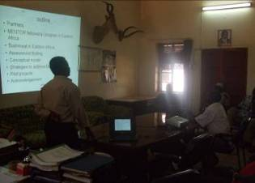
Power point presentation by MENTOR Fellow Peter Amum at The Ministry of Environment, Wildlife Conservation and Tourism in Southern Sudan, October 2008 (photo credit: Peter Amum).
Appendix 1: Communication Strategy Development and Implementation

One of the most important steps in developing a bushmeat network for eastern Africa is to develop and implement a comprehensive communications strategy. The role of the communications strategy is help sensitize stakeholders about the bushmeat trade in eastern Africa in order to reduce bushmeat consumption throughout the region. The activities for implementing the communications strategy include stakeholder identification, communication tools, communications objectives, target audiences, and a call to action and key messages. (See: Figure 2.)

Figure 2: Communications Strategy Development and Implementation
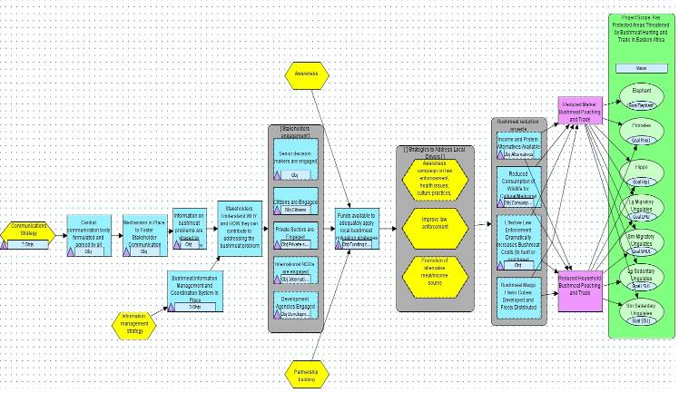
Key:
Strategy Activity (implementing the strategy) Result (expected)

Impact on target (expected) List of objectives for details) Link “If…, then…”
Communications Objective
By the end of 2009, design and begin implementation of a communications effort for the Bushmeat-free Eastern Africa Network (BEAN) that engages key partners to commit to supporting the management of bushmeat in the selected key protected areas of Maasai Mara Game Reserve in Kenya, Serengeti in Tanzania, Jonglei landscape in Southern Sudan, and Murchison Falls Conservation Area in Uganda.

Strategy Objectives
By the end of 2009, design and begin implementation of the Bushmeat-free Eastern Africa Network (BEAN) communications effort that engages key partners to commit to supporting the management of bushmeat in a key protected area.

By the end of 2009, stakeholders are sensitized on the bushmeat management and information communication system.

Activities to be pursued
- Identify stakeholders: analyze their current activities and programs, and identify their potential role in bushmeat solutions; prepare bushmeat messages; hold meetings with stakeholders individually to discuss and share messages; develop workshops in each country to bring all stakeholders together to discuss a potential partnership; develop procedure and rules for stakeholder engagement.

- Create bushmeat information packet including fact sheets of the Fellows’ bushmeat field assessments and species affected by the illegal bushmeat trade); develop a management and coordination team; develop an action plan for coordinating the team's activities; team facilitates agreement on information sharing; Collaboration with BCTF IMAP; lay the foundation for developing the first Eastern Africa State of the Bushmeat Trade Report (2009).

- Develop communication key messages to each group of stakeholders.

- Develop communication tools (e.g. website, meetings, reports, TV, radio, newspapers, presentations).

Objectives:
By the end of 2009, at least five key stakeholders from each country (Kenya, Southern Sudan, Tanzania, and Uganda) are sensitized through the communications strategy.

By the end of 2009, action plans for multi-sector engagement (private industry, government, development agencies, international NGOs) have been developed that detail specific roles, responsibilities, benefits and outcomes for each type of stakeholder engagement.

By the end of 2009, the initial procedures for sharing of information among the Bushmeat-free Eastern Africa Network (BEAN) stakeholders developed.

By the end of 2013, the BEAN Information Management System produces annual reports on the state of the bushmeat trade in Eastern Africa with particular focus on progress in named key protected areas and on target species.

By the end of 2009, 50% of senior decision makers in Kenya, Southern Sudan, Tanzania, and Uganda decide in favor of bushmeat reduction strategies.

By the end of 2009, 25% of the general public is aware of the bushmeat problem and take responsibility to address it.

By the end of 2009, at least three private sector agencies in each country engage in support of bushmeat strategies.

By the end of 2009, at least three international NGOs in each country support bushmeat reduction strategies around at least one key protected area in eastern Africa.

By the end of 2009, at least three development agencies in each of the selected eastern Africa countries engage in bushmeat reduction strategies around at least one key protected area.

By the end of 2010, funding secured to adequately address bushmeat poaching and trade (enforcement, alternatives, awareness) through MOU-signed partnerships in at least one key protected area in the eastern Africa.

By the end of 2013, prosecution success rate on bushmeat cases increased by 25% in Eastern Africa.

Stakeholder Identification
The identification of stakeholders must be based on their current roles, activities and potential roles in bushmeat reduction strategies. The stakeholders range from the government agencies (national and local), conservation NGOs, local communities, donors, development agencies, professional associations, and the private sector.

Communication Plans and Key Messages to Target Stakeholder Groups

Government Agencies (National and Local)
Call to Action • Draft and support laws to ban the illegal trade of bushmeat
• Influence change in policy and laws
Strategy / Activities • Networking and lobbying
Tools • Meetings, Bushmeat information packet
Key Message • Bushmeat consumption hampers protection and sustainability of
resources
Person Responsible • Fellows and Mentors
Key Stakeholders by Country:
Kenya: • Kenya Wildlife Service, Kenya Tourist Board, the Mara Conservancy,
Narok Country Council, Provincial Administration
Southern Sudan: • Ministry of Environment, Wildlife and Tourism
Tanzania: • Tanzania National Parks Authority (TANAPA), Wildlife Division (WD),
Ngorongoro Conservation Area Authority (NCAA), Tanzania
Wildlife Research Institute (TAWIRI), Agricultural Division
Uganda: • Uganda Wildlife Authority, National Environment Management
Authority, Ministry of Tourism, Government Analytical Laboratory
Conservation NGOs
Call to Action • Collaboratively raise awareness on the bushmeat trade problems in
Eastern Africa.
• Initiate further field projects leading to reduction of bushmeat problems
Strategy / Activities • Workshops and collaborative strategy planning
• One on one meeting between Mentors, Fellows and NGOs
Tools • Meetings, Posters, Reports, Presentations, Short film
Key Messages • There is a decline in wildlife populations due to the bushmeat trade
Person Responsible • Fellows
Key Stakeholders By Country:
Kenya: • Born Free Foundation, Frankfurt Zoological Society, East Africa Wildlife
Society, Friends of Conservation, Wildlife Clubs of Kenya, African
Wildlife Foundation
Southern Sudan: • Wildlife Conservation Society
Tanzania: • African Wildlife Foundation (AWF), Wildlife Conservation Society,
WWF, Frankfort Zoological Society, Convention on International Trade
in Endangered Species of Wild Fauna and Flora (CITES), Monitoring of
Illegal Killing of Elephant (MIKE)
Uganda: • Wildlife Conservation Society, WWF, Jane Goodall Institute,
Greenwatch, Uganda, Wildlife Education Center, Nature Uganda,
Wildlife Club of Uganda, CARE, Oxfam
Local Communities
Call to Action • Stop eating bushmeat
• Stop poaching
• Stop trading bushmeat
Strategy / Activities • Meetings, Seminars
Tools • Meetings, Posters, Presentations, Short film, Radio advertisement
Key Message • Bushmeat consumption can lead to risks such as jailed, zoonotic
disease infections and slow development
• There are alternative proteins and incomes activities available

Person Responsible • Fellows
Key Stakeholders • Community Based Organizations (CBOs), tribal chiefs, religious groups,
women’s groups, school children, teachers, etc.
Donors
Call to Action • Provide funding for bushmeat reduction strategies and information
communication strategies (i.e. stakeholders workshops, information management, protein alternatives, awareness campaigns, law enforcement, income alternatives).
Strategy / Activities • Approach donors and emphasize the need to promote the sharing of
bushmeat data and to fund the suggested bushmeat solutions
• Submit proposals for funding of information sharing and
identified solutions to the bushmeat trade
Tools • Introduction letters, Meetings, Emails, Phone calls, Proposals, Short
Films
Key Message • Wildlife consumption and trade are top drivers of biodiversity loss
Person Responsible • Fellows
Key Stakeholders • Bilateral donor agencies, multilateral donor banks

Development Agencies
Call to Action • Incorporate conservation values into their projects
• Share information & resources between projects
• Help on development projects that lead to reduction of bushmeat
hunting/consumption
Strategy / Activities • Website for posting and sharing of project documents and information,
Meetings, Workshops for collaborative strategy planning
Tools •Website, Meetings, Reports, Presentations
Key Message •Wildlife conservation is a key to sustainable development
• Loss in wildlife is a loss of alternatives for development (e.g. potential
for ecotourism)
Person Responsible • Fellows
Key Stakeholders • United Nations Higher Commissioner for Refugees (UNHCR),
Africare, Heifer International, Care International, Africare, VETAID,
IFAD, Heifer International, Oxfam, Farm Africa

Private Sector and Professional Associations
Call to Action • Promote alternative employment for the bushmeat traders
•Spread information on the effect of bushmeat consumption
•Help funding bushmeat reduction strategies
Strategy / Activities • Networking and lobbying
Tools • Meetings, Information packet
Key Messages
For hunting companies • Illegal wildlife consumption jeopardizes future existence of wild animals
For breweries, media, telephone companies
•Protection and sustainability of resources are needed for ecosystem
services (water, air, soil, rainfall)
Person Responsible •Program co-coordinator, MENTORS and Fellows
Key Stakeholders by Country:
Kenya: •Kenya Professional Safari Guides Association, Kenya Veterinary
Association
Tanzania: •Hotel Association of Tanzania (HAT), Tanzania Wildlife Exporters Association (TWEA), Tanzania Hunting Operators Association (TAHOA)
Hunting companies (Tanzania Game Trackers, Grumeti, Tanzania Big Game
Uganda: •Uganda Taxi Operators Association (UTODA)
General tools that can be specifically adopted in a country and audience

♦ Promotional Tools
Billboards , Posters , Community Gatherings , Music (message through lyrics) ,T-shirts , Caps, Bags ,Stickers, Calendars, Newsletters, Pens/Pencils, Key Chains/Badges, Brochures, Banners , Internet and World Wide Web

♦ Radio
Talk shows, News, Drama, Plays, Religious programs, Forums for specific audiences, Advertisements and Entertainment.

♦ Print Media
Newspapers, Magazines, Feature stories, Editorials, Opinion editorials, supplements and Advertisements.

♦ Television
News, Feature stories, Documentaries, Talk shows and locally produced drama

♦ Events
Festivals, Contests (photo, essay), Religious events, Community gatherings, Conferences, workshops, seminars, Concert, Theater/drama, Photo exhibitions, Video screenings, Booths at events and Journalist training.

♦ Schools
Teacher’s manuals, Teacher training, National curriculum development, Library collections, School field trips, Cartoons and storybooks, Eco clubs, Parades, Children’s contests, Experiments and research, Drama (puppet shows, skits), Mobile exhibits, Newspaper inserts for kids, Murals, School gardens, Games and Conservation projects, Music (festivals, songs).

Appendix 2: Partnership Strategy

Developing partnerships is critical to building a bushmeat network for implementing bushmeat solutions throughout the eastern Africa region. Partnerships are needed between government agencies (national and local), conservation NGOs, local communities, donors, development agencies, professional associations, and the private sector to work together on bushmeat solutions. Steps involved in building successful partnerships include developing Memorandums of Understanding (MOUs) for forming partnerships, identifying potential institutional conflicts, and recommending solutions.

Activities for catalyzing partnerships include interviewing experts in partnership development to identify steps, roles, and mechanisms on successful partnership building; conducting a literature review on partnership building, identifying roles and responsibilities, and gathering sample MOUs.

The Fellows will help develop MOUs between partners agreeing to commit to addressing the bushmeat issue in the four identified protected areas [1) Maasai Mara, Kenya, 2) Jonglei landscape, Southern Sudan, 3) Serengeti, Tanzania, and 4) Murchison Falls, Uganda].

The Fellows will identify potential stakeholders in these selected protected areas. They will develop key messaging and tools to raise awareness, and will identify perspectives among potential partners for desired outcomes (e.g. consensus building and finding common ground). See Figure 3.

Figure 3: Results Chain on Partnership Building

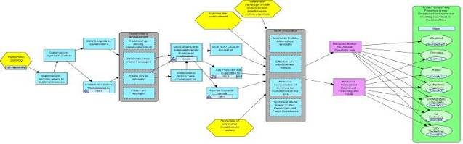

Objective

By the end of 2009, establish at least one committed 5-year partnership associated with a key protected area in Kenya, Southern Sudan, Tanzania, Uganda confirmed by a signed MOU.

By the end of 2009, at least one identified key protected areas in eastern Africa (Maasai Mara, Jongeli, Serengeti, Murchison Falls) have functional public-private-government partnerships that are directly addressing bushmeat poaching and trade.

Indicators
# of partnerships operational in key protected areas (including # of MOU’s signed)

Objective
By the end of 2010, each selected country has a partnership leadership team (composed of professionals/ experts/ senior officials) skilled in building partnerships that can work with the Bushmeat-free Eastern Africa Network.

Indicator
# of functional partnership leadership teams in each of the four eastern Africa countries

Objective
By the end of 2010, each country has a conflict resolution committee in place (composed of professionals/experts skilled in conflict resolution mechanism that can work with the Bushmeat-free Eastern Africa Network).

Indicator
# of functional conflict resolution committees in place

Objective
By the end of 2010, funding secured to adequately address bushmeat poaching and trade (enforcement, alternatives, awareness) through MOU-signed partnerships in at least one key protected areas.

Monitoring Plan
Objective 1 | By the end of 2009, at least one functional public-private-government partnership for identified key protected areas is directly addressing bushmeat poaching and trade.
Indicators | # of signed MOUs
What? | Number of signed MOUs
When? | By June 2009
Who (responsible) | MENTOR Fellow
Who (analyze) | MENTOR Fellow
Where | In each key protected area
Objective 2 | By the end of 2010, each country has a partnership leadership team (composed of professionals/experts/senior officials skilled in building partnerships that can work with the Bushmeat-free Eastern Africa Network).
Indicators | Partnership leadership team in place
What? | Partnership leadership team is in place
when | By June 2010
Who (responsible) | MENTOR Fellow
Who (analyze) | MENTOR Fellow
Where | In each key protected area
Objective 3 | By the end of 2010, each country has a conflict resolution committee in place (composed of professionals/experts skilled in conflict resolution mechanism that can work with the Bushmeat-free Eastern Africa Network).
Indicators | Conflict resolution committee in place
when | By June 2010
Who (responsible) | MENTOR Fellow
Who (analyze) | MENTOR Fellow
Where | In each key protected area

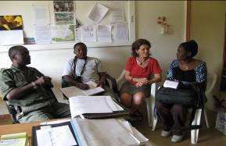

Meeting between USFWS MENTOR Fellows and Senior Staff of Singita Grumeti Company Ltd. Nov. 2008
Appendix 3: Awareness Strategy

Cultural and medicinal use of bushmeat and preference for bushmeat taste are among the contributing factors to commercial and subsistence hunting. This has led to an increase in demand for the bushmeat trade that has moved from rural to urban areas. In addition ineffective law enforcement makes it easy for hunters to trade bushmeat and therefore earn high revenue. Bushmeat is often very profitable. Contributing to this is the lack of knowledge on animal reproduction and behavior and the impact of bushmeat consumption on human health risks in eastern African countries. Therefore, an awareness strategy is needed to raise public understanding on law enforcement, health issues, and cultural practices. See Figure 4.

Figure 4: Results Chain of Awareness Strategy

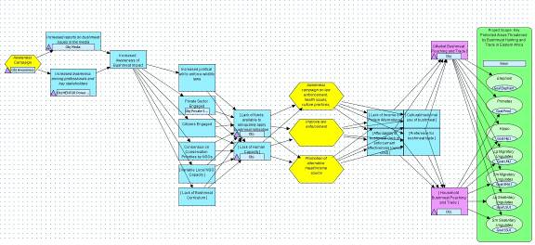

Objectives

By July 2009, at least 70% of the population in eastern Africa will be aware of bushmeat issues.

By July 2009, in awareness media there will be 50% increase from 2008 bushmeat reporting in leading media (e.g. TV, newspapers and radio).

By July 2009, 25 presentations will be done per country in eastern Africa and at the site level.

By July 2009, funding will be secured to adequately address awareness on bushmeat poaching and trade in at least in one key protected area in eastern Africa.

Bushmeat Awareness Tools
For bushmeat awareness, a number of tools will be used to target different groups in the different areas of the study including:

Promotional Tools
Billboards, posters , community gatherings, music, t-shirts, caps, bags ,stickers, calendars, newsletters, pens/pencils, key chains, badges, brochures, banners, and the internet

Radio
Talk shows, news, drama, plays, religious programs, advertisements and entertainment

Print Media
Newspapers, magazines, feature stories, editorials, opinion pieces, supplements and advertisements.

Television
News, feature stories, documentaries, talk shows and locally produced drama

Actions
Festivals, photo exhibitions, essays, religious events, community gatherings, conferences, workshops, seminars, concerts, theater/dramas, video screenings, booths at events, and journalist training.

Monitoring Plan

Objective 1 | By July 2009, at least 70% of the population in eastern Africa will be aware of bushmeat issues
Indicators | # of general public aware of bushmeat issues in eastern Africa
What | # of general public aware of bushmeat issues
How | Pre and post surveys will be conducted through questionnaire to community leaders attending meetings.
When | By June 2009
Who (responsible) | MENTOR Fellow
Who (analyze) | MENTOR Fellow
Where | Throughout eastern Africa
Objective 2 | In awareness media, by the end of 2009 there will be 50% increase from 2008 bushmeat reporting in leading media (TV, news papers and radios)
Indicators | # of reports in TVs, newspapers and media
What | # of reporting done
How | The assessment will be conducted by analysis of reports before and after awareness campaign
When | By June 2009
Who (responsible) | MENTOR Fellow
Who (analyze) | MENTOR Fellow
Where | Throughout eastern Africa
Objective 3 | By the end of 2009, 25 presentations will be done per country in eastern Africa and at the site level.
Indicators | # of presentations
What | # of new public reforming
How | The assessment will be conducted through questionnaire before and after awareness
When | By June 2009
Who (responsible) | MENTOR Fellow
Who (analyze) | MENTOR Fellow
Where | In each key protected area
Objective 4 | \09. funding secured to adequately address awareness on bushmeat poaching and trade (in at least one key protected areas in eastern Africa).
Indicators | Amount of funding available
What | Funding available
How | The assessment will be conducted before and after conducting presentations.
When | By June 2009
Who (responsible) | MENTOR Fellow
Who (analyze) | MENTOR Fellow
Where | In each key protected areas
Objective 5 | By July 2009, at least 70% of markets for bushmeat trade will decrease in eastern Africa.
Indicators | # of bushmeat sellers being closed down
What | Closing down of bushmeat markets
How | Group interview, meetings
when | By June 2009
Who(responsible) | Mentor fellow
Who(analyze) | Mentor fellow
Where | Adjacent to key protected areas
Objective 6 | By July 2009, at least 70% of household bushmeat poaching and trade will decrease in Eastern Africa
Indicators | # of household not eating bushmeat
What | Households not eating bushmeat
How | Services of expert to be sought
when | By June 2009
Who(responsible) | Mentor fellow
Who(analyze) | Mentor Fellow
Where | In key protected areas

Appendix 4: Information Management

The Bushmeat-free Eastern Africa Network will gather bushmeat project information from the region for analysis by the BCTF Bushmeat Information Management and Analysis Project (IMAP). The results will contribute to an annual bushmeat report to be shared with media, key decision makers and partners in key protected areas. See Figure 5.

Figure 5: Results Chain on Information Management

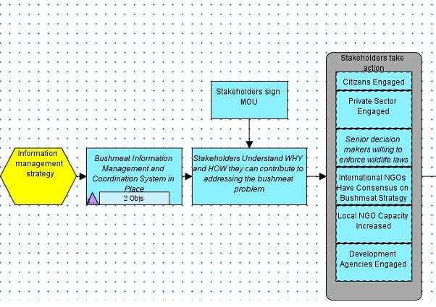
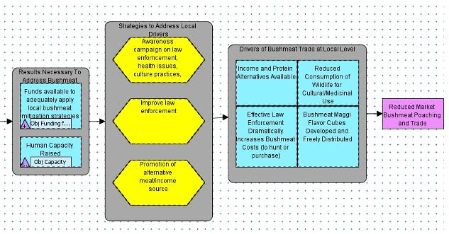

Objective
By the end of 2013, the Bushmeat-free Eastern Africa Network’s Information Management System produces annual reports on the state of the bushmeat trade in Eastern Africa with particular focus on progress in named key protected areas.

Activities/Tasks
- Fill out BCTF bushmeat project report forms
- Create a Bushmeat-free Eastern Africa Network (BEAN) website or weblog
- Collect contacts for key organizations in respective areas
- Submit monthly updates in the website or weblog
- Post factsheets on website and distribute information on bushmeat in eastern Africa to stakeholders and others looking for bushmeat information in their respective areas.

Appendix 5: Awareness Campaign in Key Protected Areas

In order to deal with the bushmeat issue around key protected areas, site level awareness campaigns are needed. The awareness campaigns will target the following audience: community leaders, teachers, religious groups, and the local media. The campaign will increase knowledge about the values of wildlife, the impact of bushmeat hunting and consumption to wildlife populations, and increased awareness about the health risk of hunting and consuming bushmeat. As a result of the increased awareness, community leaders, teachers, religious leaders and local media will help to educate the communities (e.g. hunters and consumers) to choose alternatives to bushmeat and support enforcement of wildlife laws. Through partnerships with government agencies (national and local), conservation NGOs, local communities, donors, development agencies, professional associations, and the private sector found within their area. The campaign will provide incentives and awareness about alternative sources of protein and income generating alternatives. The campaign will be considered a success by reducing bushmeat hunting, consumption, and increasing or stabilizing population of targeted species in the key protected areas site by 70% in 2013. See Figure 6.

Figure 6: Results Chain on Awareness Campaign in Key Protected Area

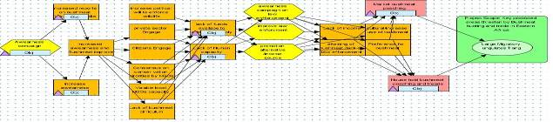

Objectives:

Community leaders

By the end of 2009, 40% of community leaders around key protected areas are aware of the impact of bushmeat on wildlife and human health risks.

Teachers

By the end of 2009, 40% of teachers around key protected areas aware of the value of wildlife, and the impact of bushmeat hunting on wildlife and the human health risks of consuming bushmeat.

Religious leaders

By the end of 2009, 40% of religious leaders are aware of and appreciate the impact of bushmeat hunting on wildlife and health risks in key protected areas in eastern Africa.

Media

By June 2009, local media coverage on bushmeat will increase by 40% from current level

Monitoring Plan

Objective 1 | By the end of 2009, 40% of community leaders around key protected areas aware impact of bushmeat on wildlife and human health risks
Indicators | # of community leaders addressing bushmeat  # of people abandon eating bushmeat  # of people abandon bushmeat trade
What | # of community leaders participating in organizing activities on bushmeat issues
How | The pre and post survey will be conducted through a questionnaire to community leaders.
when | By June 2009
Who (responsible) | MENTOR Fellow
Who (analyze) | MENTOR Fellow
Where | In each key protected area
Objective 2 | By 2009, 40% of teachers are aware of the value of wildlife, impact of bushmeat hunting and health risks of consuming bushmeat in area around/adjacent to key protected areas.
Indicators | # of teachers participating to organize activities related to bushmeat (e.g. debate, competition among the students)
What | # of schools incorporating bushmeat issues in their curriculum
How | The assessment will be conducted through a questionnaire before and after conducting meeting/workshops to school teachers.
When | By June 2009
Who (responsible) | MENTOR Fellow
Who (analyze) | MENTOR Fellow
Where | In each key protected area
Objective 3 | By the end of 2009, 40% of religious leaders are aware and appreciate the impact of bushmeat hunting on wildlife and health risks
Indicators | # of religious leaders who discuss bushmeat issues with their followers  # of meeting conducted to discuss bushmeat issue with the religious leaders
What | # of religious leaders leading the discussion on bushmeat issues with their church /mosque members
How | The assessment will be conducted through a questionnaire before and after conducting meetings/workshops to school teachers.
When | By June 2009
Who (responsible) | MENTOR Fellow
Who (analyze) | MENTOR Fellow
Where | In each key protected area
Objective 4 | By June 2009 media coverage increased by 40% from current levels
Indicators | # of media reporting on bushmeat issues  frequency of bushmeat covered in media
What | Media reporting on bushmeat issues  Theater related to bushmeat issues organized by local performing groups
How | List of reports on bushmeat issues in the media
When | By June 2009
Who (responsible) | MENTOR Fellow
Who (analyze) | MENTOR Fellow
Where | In each key protected areas
Comments | After information is collected and analyzed, the results will be shared during conference organized at Mweka College in June 2009.

Appendix 6: Protein Alternative Partnerships

Based on the bushmeat field assessments conducted by the USFWS MENTOR Fellows in April and May 2008, it is clear that bushmeat is the main source of meat and source of income for many communities near protected areas. Bushmeat is not only consumed for subsistence, but it is sold in order to purchase other food items such as sorghum and maize. The drivers of the bushmeat trade and consumption in many areas are poverty and the need for protein. Efforts should be made to create alternative sources of meat and income for communities to reduce pressure on wildlife while the traditional livelihood activities such as crop production and livestock rearing should be encouraged and improved.

Strategy
Promotion of alternative sources of protein was identified as a potential bushmeat solution in order to reduce the threat to wildlife. This will have direct impact on bushmeat off take and will reduce the pressure on wildlife for communities who depend on wild animals as a source of protein and food. The strategy involves working with key stakeholders including community leaders, NGOs, development and humanitarian relief agencies, donors, private sector, livestock and poultry sectors, food security, and health sector. It is important to raise awareness on the linkages between bushmeat and health, and food security. Local people must understand how emerging infectious diseases can be spread by the slaughter and consumption of bushmeat, and how this poses risks to wildlife, livestock and human health. Development agencies, livestock and poultry sectors, and the private sector working on protein alternatives must be encouraged to work with communities adjacent to protected areas. See Figure 7.
Figure 7: Results Chain on Protein Alternatives

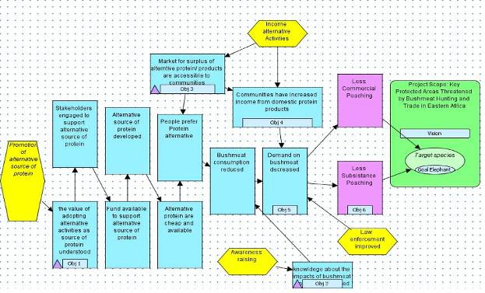

Objectives:

By the end of 2013, there will be a 75% increase in understanding of the value of adopting alternative sources of protein for selected communities adjacent to key protected areas.

By the end of 2009, there will be a 70% increase awareness about diseases and the risk of consumption of bushmeat.

By the end of 2009, 30% increase in access for domestic protein production markets for these selected communities.

By the end of 2013, there will be a 20% increase in target species within key protected area from current population estimate.

Monitoring Plan
Objective 1 | By the end of 2013, there will be a 75% increase in understanding of the value of adopting alternative sources of protein for selected communities in key protected areas.
Indicator | # of meetings with the communities  # of wildlife disease films viewed by communities
What | # of community members participating in meetings.  # of wildlife diseases film presented
How | Direct field survey with communities
When | By June 2009
Who | MENTOR Fellow
Who | MENTOR Fellow
Where | In each key protected area
Objective 2 | By the end of 2009, there will be a 70% increase in awareness about bushmeat consumption and diseases.
Indicator | # of meetings with the communities  # of presentations about bushmeat issues  # of wildlife disease films viewed by communities
What | # of community members participating in meetings
How | Direct survey in villages in and around the key protected area
When | By June 2009
Who | MENTOR Fellow, Health Sector
Who | MENTOR Fellow
Where | In each key protected area
Objective 3 | By the end of 2009, 50% increase in access for domestic protein production market for community from the current level.
Indicator | # of the domestic livestock markets accessible to the community.  # of the household consumed domestic products.
What | # of the markets for domestic products accessible.  # of household consumed domestic products.
How | Direct field survey.  Direct household survey.
When | By June 2009
Who | MENTOR Fellow, private sector, development agencies
Who | MENTOR Fellow
Where | In each key protected area
Goal | By the end of 2013, there will be a 20% increase targeted species within the key protected area from the current population estimate
Indicator | # of the target species within key protected area
What | Survey of the target species
How | Direct field monitoring and survey
When | By June 2009, the starting of the project
Who | MENTOR Fellow, protected area and wildlife authorities, NGOs
Where | In key protected areas

Appendix 7: Income Alternatives Partnerships

The bushmeat field assessment findings in Uganda revealed that poverty and the lack of alternative means of livelihood were among the main drivers to bushmeat trade and consumption in both the rural and urban towns surveyed. Results also showed that taste and cultural attachment to bushmeat drive the trade, but this can be offset if significant benefits and time management of the poachers are taken care of. Most poaching activities are carried out in the dry season and this coincides with the period when there is general work redundancy in the rural areas. If this time can be used to engage the poachers in significant income generating activities together with awareness, partnership, and law enforcement strategies then there can be a reduction in bushmeat trade and consumption.

Addressing bushmeat issues using an alternative income generating pilot project at the site level in Murchison Falls Conservation Area (MFCA) will begin from 1 September 2008 until 31 May 2009. The alternative income generating activities will target the reformed poachers groups around MFCA (see Table 3 below). The strategy seeks to increase income for the groups by promoting and supporting alternatives through partnerships with development organizations, the private sector, professional associations, and conservation agencies found within their area. The campaign will provide incentives for alternative sources of income. It will be considered a success by reducing bushmeat hunting, consumption, and increasing or stabilizing populations of targeted species in the key protected areas site by 70% in 2013. See Figure 8.

Figure 8: Results Chain on Income Alternatives

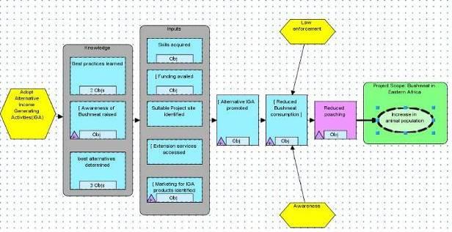

Table 3: Ex-Poachers Groups Around Murchison Falls Conservation Area, Uganda

No. | Group Name | Total No. | Sub-County | District
1 | Kamdini | 326 | Aber | Oyam
2 | Can Uterare | 156 | Pakwach | Nebbi
3 | Can Lalomer | 145 | Nyaravur | Nebbi
4 | Can Lalonindo | 136 | Erusi | Nebbi
5 | Tim Kihabucan | 99 | Kucwiny | Nebbi
6 | Can Rac | 101 | Biiso | Buliisa
7 | Pyem Odwono Cwee | 54 | Buliisa | Buliisa
8 | Kicwabugingo | 26 | Kiryandongo | Masindi
9 | Awanya Tandatho | 30 | Mutunda | Masindi
10 | Ajigo Tim | 101 | Erusi | Nebbi
11 | Boro | 86 | Panyimur | Nebbi
12 | Tim Ucama | 84 | Nyaravur | Nebbi
13 | Anaka | 61 | Anaka | Gulu
14 | Warek Dwar | 110 | Purongo | Gulu
15 | Kiruli | 57 | Pakanyi | Masindi
16 | Okwer Angira | 97 | Pakanyi | Masindi
17 | Chotembu Ilum | 52 | Pakanyi | Masindi
18 | Can Uterare | 126 | Kigumba | Masindi
19 | Diima | 43 | Mutunda | Masindi
20 | Akunu Dwar | 84 | Purongo | Gulu
21 | Can Dek | 73 | Mutunda | Masindi
 | Total | 2047
Source: Uganda Wildlife Authority 2008

Objectives
- By the end of 2009, 70% of reformed poachers around Murchison Falls Conservation Area (MFCA), Uganda, learn about best practices for alternative income generating activities.

- By the end of 2009, best practices for alternative income generating activities appropriate for MFCA will be identified and demonstrated effectively.

- By the end of 2009, 70% of the reformed poachers are aware of alternative income generating activities in MFCA.

- By the end of 2009, 10 presentations will be made to institutions with expertise in developing alternative income generating activities.

- By the end of 2009, 25 interviews will be held with reformed poacher groups around MFCA.

- By the end of 2009, communication mechanisms will key messages, factsheets, and other communication materials will be in place for stakeholder engagement in and around MFCA.

- By the end of 2009, 70% of the reformed poachers around MFCA will acquire skills in alternative income generating activities.

- By the end of 2009, 70% of reformed poachers have access to resources necessary to adopt alternative income generating activities around MFCA.

- By the end of 2009, reformed poachers around MFCA have market access for their income generating products.

- By the end of 2009, 50 poachers reform their practices around MFCA.

- By 2013, 70% reduction in bushmeat consumption in MFCA.

Appendix 8: Law Enforcement and Prosecution

Eastern Africa is experiencing declines in wildlife populations. This calls for a strong and multifaceted action by every institution that has a role to play in the conservation of wildlife to take an appropriate action. Tanzania and Uganda have effective conservation laws with strongly deterrent sentences in place, but with an inadequate enforcement mechanism. Kenya, Tanzania, and Uganda apply commonwealth legal systems by virtue of their being former British colonies. Case law decisions pronounced in each of the three jurisdictions are either binding or persuasive. Yet poverty, lack of economic alternatives, and incomplete law enforcement are among the factors driving the unsustainable utilization of bushmeat in East Africa. The impact of these illegal activities on the survival of wildlife species underlies the need for strong penalties that reflect the harm caused. This must be imposed at all levels of wildlife law enforcement. See Figure 9.

Problem Statement

Although there are supportive legislative frameworks for prosecuting incidences of illegal bushmeat utilization in practice, bushmeat cases are treated as minor offences by police and courts in Eastern Africa resulting in terms of sentences that do not provide an appropriate deterrence to the offender. The sentencing does not take into account the full range of the options available to courts. This does not consider the efforts and cost incurred in investigations, arrest, and prosecution of the suspects. This is because it is only the wildlife law enforcement officers, protected area wardens, and wildlife ranger forces that are fully aware of the impact of illegal utilization of bushmeat on wildlife conservation.

Wildlife law enforcement activities are conducted in three stages:

Stage One: Information Gathering
The first stage involves the information gathering process. Informers are recruited by wildlife law enforcement officers to give information about illegal wildlife related activities. Investigations are conducted and suspects are arrested by wildlife law enforcement officers.

Stage Two: Interrogation
The second stage involves the use of police in detention and interrogation of the suspects. This is because most protected areas do not have police stations and legal detention facilities. At this stage, police interfere with cases and a lot of cases are prematurely abandoned by law enforcement officers due to frustration.

Stage Three: Filing Cases for Prosecution
The third stage involves perusal and sanctioning of cases for filing and prosecution in court. At this point, many cases are frustrated by the state attorneys who are not well informed about wildlife related crimes and the few which survive the state attorneys are then produced in court for prosecution. In most cases if the suspect pleads guilty outright, there is the possibility of getting at least a weak sentence because most prosecutors fail to convince courts about the value of wildlife and why the suspects should serve their full sentences. When the case is fixed for a full hearing, it rarely succeeds.

In eastern Africa, conservation capacity development projects target the first two stages of law enforcement and no or little attention is directed at stage three. Due to the above reasons, there are underlying problems encountered during prosecution of wildlife cases including:

- Courts are not aware of the value of wildlife conservation. This because the curriculum of law faculties at universities in eastern Africa focus on environmental law and other branches of laws with no mention of wildlife laws. In Uganda, for example, wildlife laws are only covered at the graduate degree level.

- Wildlife poaching cases are treated by courts and police as minor offences since they are not aware of the effect of the bushmeat trade on protected species. In most cases, they are instituted before a grade II Magistrate which is the lowest grade with the minimal power.

- The penalties awarded by courts in wildlife crimes are not commensurate with the offence committed and the effort put in by the law enforcement officers at the initial stage of undercover investigations and arrest. This leaves many wildlife law enforcement staff frustrated.

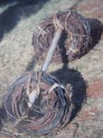
Removed bushmeat snares (photo credit: Evans Mwangi)

Figure 9: Results Chain on Law Enforcement and Prosecution

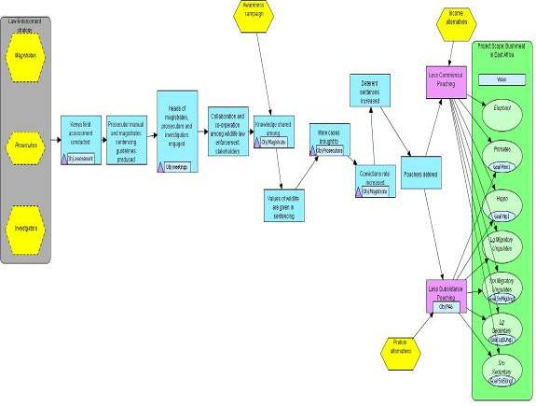

Goal
By the end of 2013, there will be 50% reduction (from 2008 estimates) in bushmeat off take in key protected areas in eastern Africa due to increase capacity to effectively address the bushmeat problem.

Objectives
- To use the utilities of the laws available in eastern Africa to conserve wildlife in key protected areas.

- To develop the capacity of wildlife law enforcement officers, police investigators, prosecutors and magistrates to enforce wildlife laws in key protected areas.

- To develop partnerships among stakeholders in wildlife law enforcement.

Regional Team Initiative on Law Enforcement in Key Protected Areas

Awareness training in wildlife laws will be conducted for prosecutors, wildlife law enforcement officers, police, and magistrates in the selected key protected areas (Maasai Mara, Serengeti, and Murchison Falls). Some key law enforcement partners are described in Table 4 below.

Table 4: Law Enforcement Partners

Partners | Location | Motivation
Lusaka Agreement Task Force | Nairobi, Kenya | fighting crimes
Judiciary | Kenya ,Tanzania, Uganda | fighting crimes
Directorate of Public Prosecution | Kenya, Tanzania, Uganda | fighting crimes
Police Department | Kenya , Tanzania, Uganda | fighting crimes
Uganda Wildlife Authority | Uganda | conservation
Kenya Wildlife Service | Kenya | conservation
Tanzania National Parks Authority | Tanzania | conservation
Tanzania Wildlife Division | Tanzania | conservation
Uganda Taxi Operators Association | Uganda | accreditation

Appendix 9: Bushmeat Field Assessment Fact Sheets (attached)

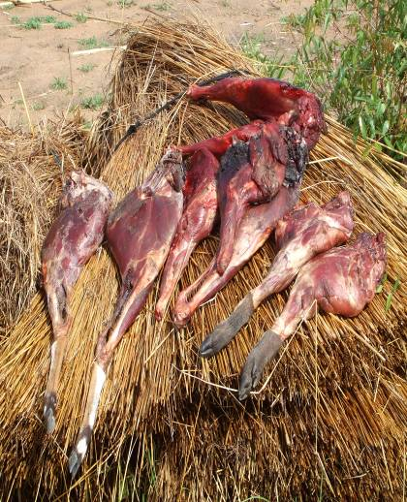
Bushmeat in Southern Sudan (photo credit: Isaac Seme)

